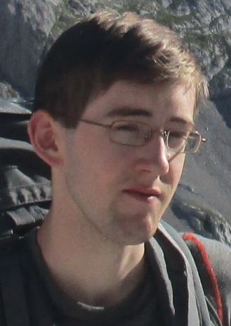
Curriculum Vitae

Name: Michael Laichmann
Adress: Anatourgasse 55
1130 Vienna
E-mail: mike17021994@hotmail.de
Telephone: 0664 34 70791
Birthdate: 17.02.1994

Education:
2004-2012 BG/BRG Purkersdorf
2012-2018 University of Vienna (Bachelor degree in Biology/Molecular Biology)
2019- University of Vienna (Molecular Biology)

Related Work Experience:

2012 Internship at the University of Salzburg
- The GEN-AU summer school provided for me the first opportunity to gather experience in the lab and become acquainted with various methods like DNA/RNA purification, preparation of histological stained tissue and RT-PCR (Three weeks)
2017 Internship at the food investigation institute Vienna (MA 38)
- Preparation and analysis of pesticide content in food samples via GC-MS and HPLC (One Month)
2018 Internship at Vienna's University of Natural Resources and Applied Life Sciences (BOKU)
- Over the course of three months I worked on the characterisation of human Peroxidasin. My responsibilities were the maintenance of cells in culture, transfection with recombinant protein and purification via affinity-chromatography. I also learned how to determine enzyme kinetics via UV/VIS- and fluorescence-spectroscopy.
2020 Internship at Max Perutz Labs Vienna (Group Otsuka)
- I was involved with a project to identify and characterise key players in the maintenance of the structure of the ER. I learned how to knock down genes in cells using siRNA and how to visualize IF labelled protein via confocal and STED microscopy.

Languages:
German – native
English – proficient

